Jenkins Installation steps in GCP

1. Create UBUNTU Instance in GCP account.

Steps:

Open GCP account🡪Go to home 🡪 Go to VM Instance🡪 Create Instance.

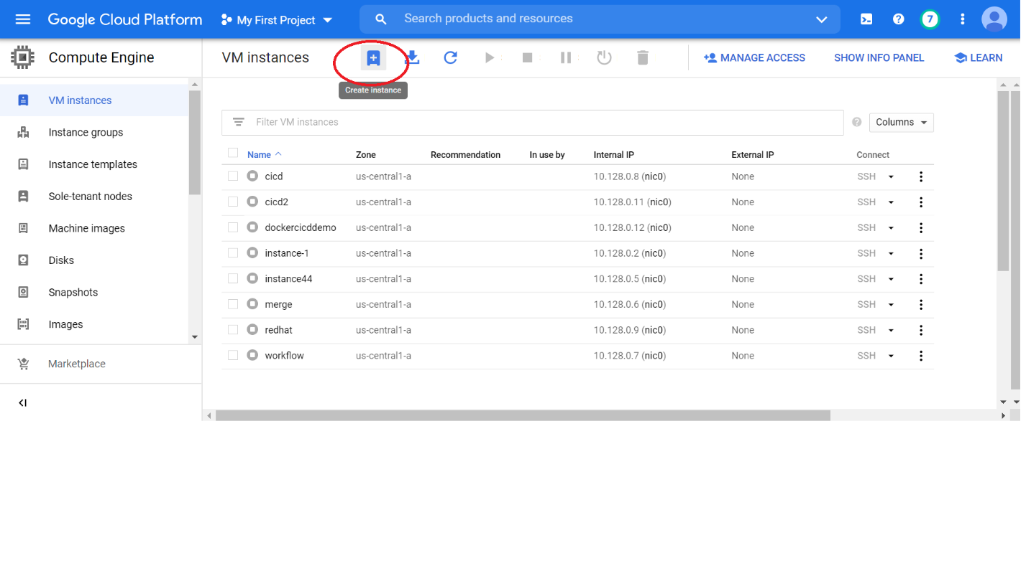

Select Machine Type e2-standrd-8(8GB memory)

Select Boot disk Ubuntu type

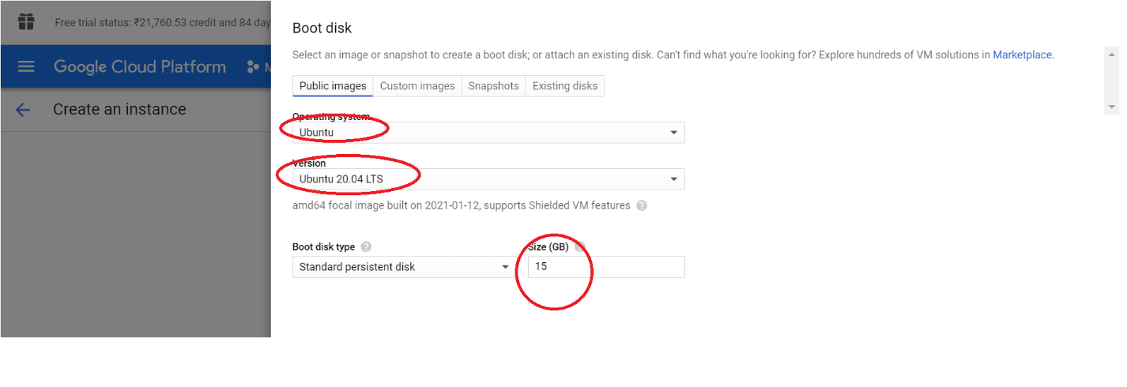finally click on create

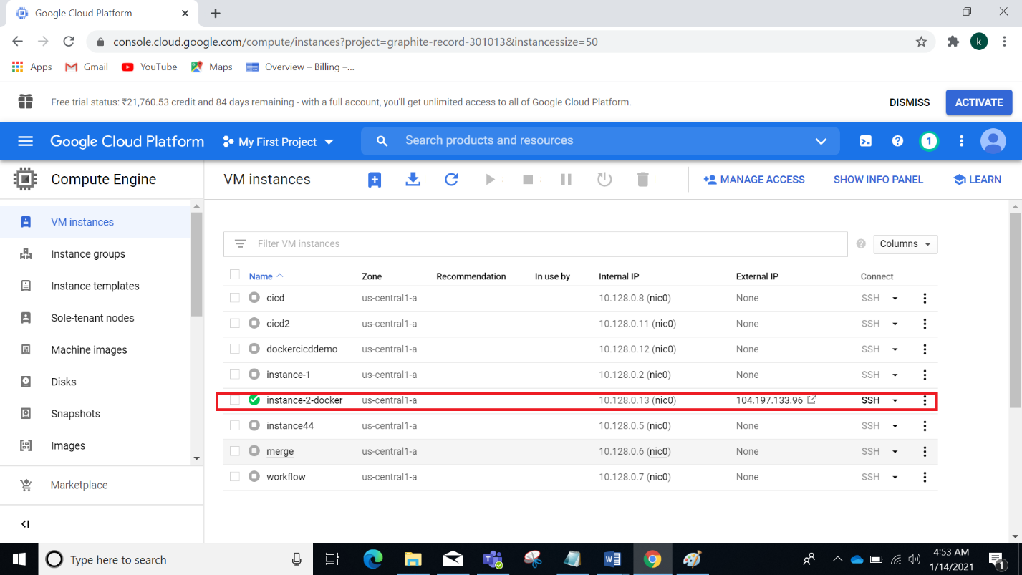

Create new private key in mobaxterm

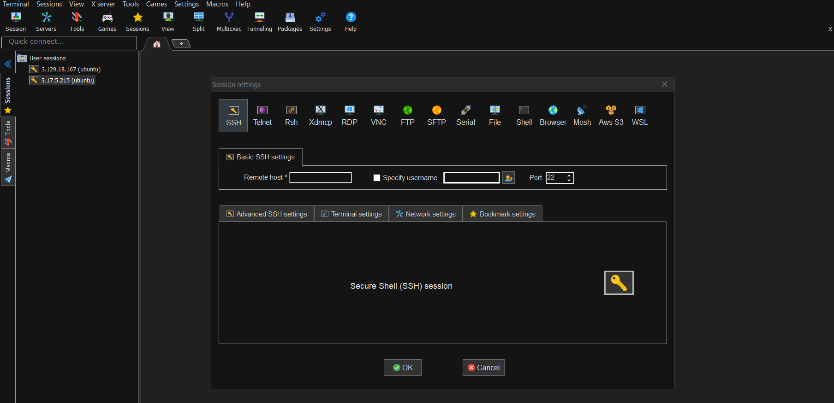

After we need to generate new private and save it as Ubuntu.ppk

Go to vm instance add key in ssh keys point.

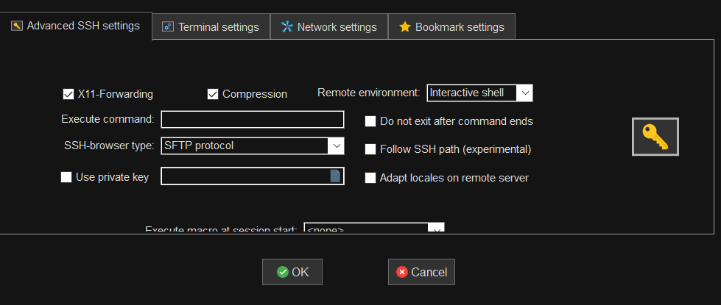

After successfully create that mobaxterm tool configuration you see window like this.

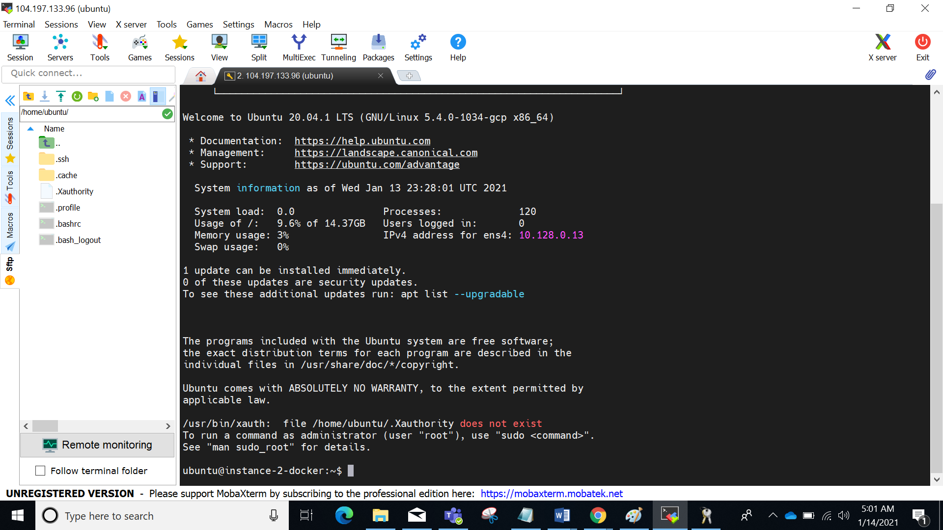

Steps:

Initiate the installation process:

Sudo apt update

Go to root directory and update the packages

Sudo su -

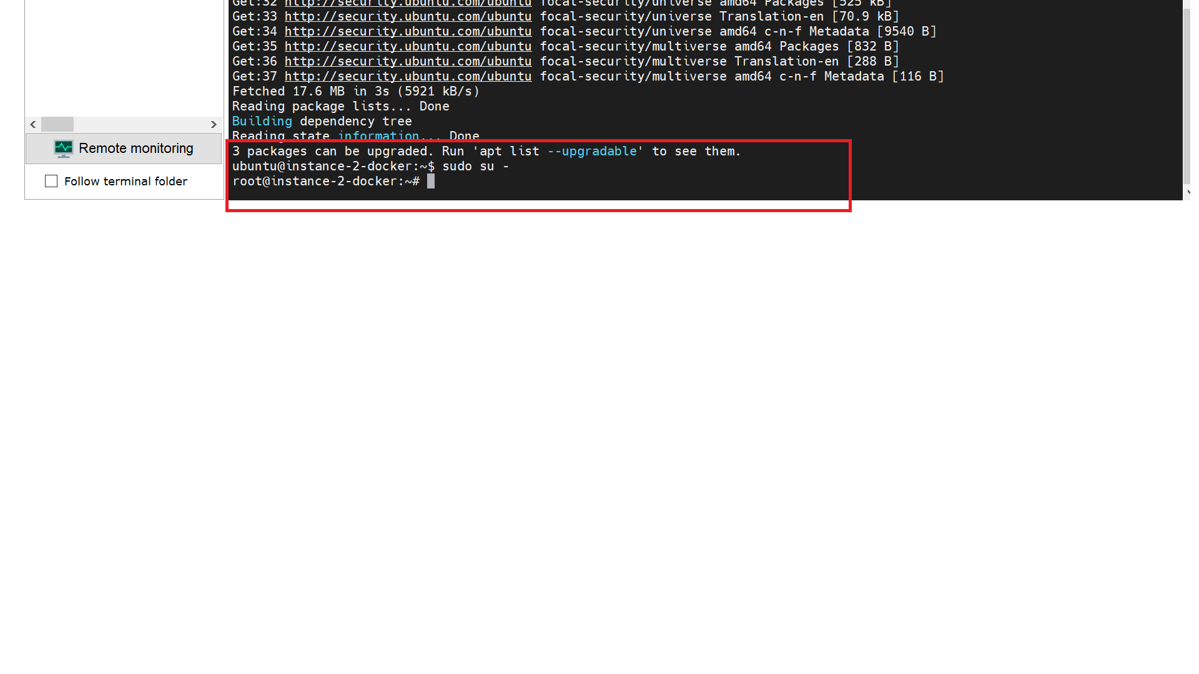

sudo apt-get update

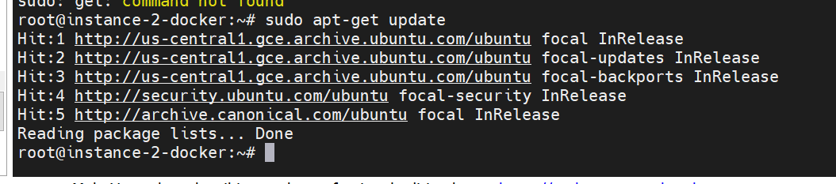

sudo apt-get install \

apt-transport-https \

ca-certificates \

curl \

gnupg-agent \

software-properties-common

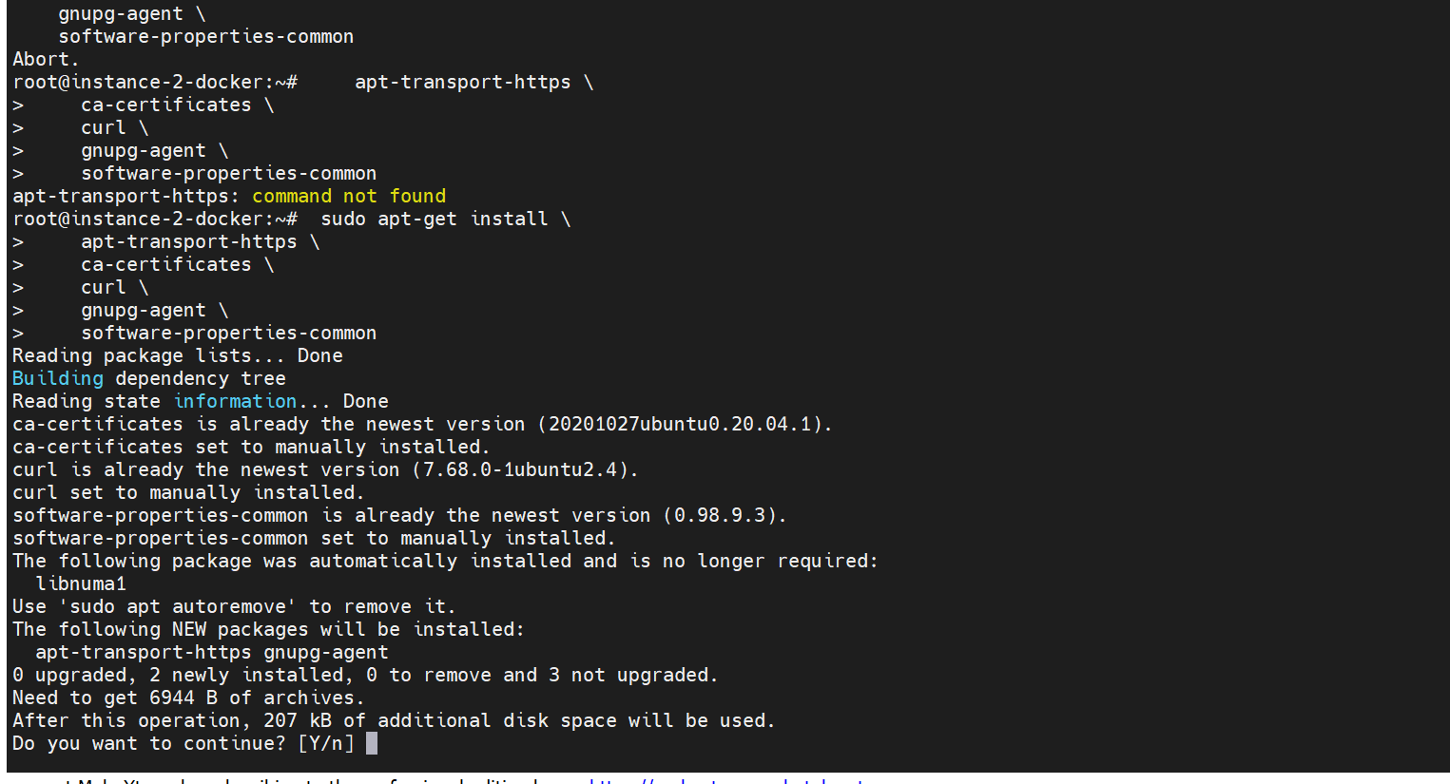

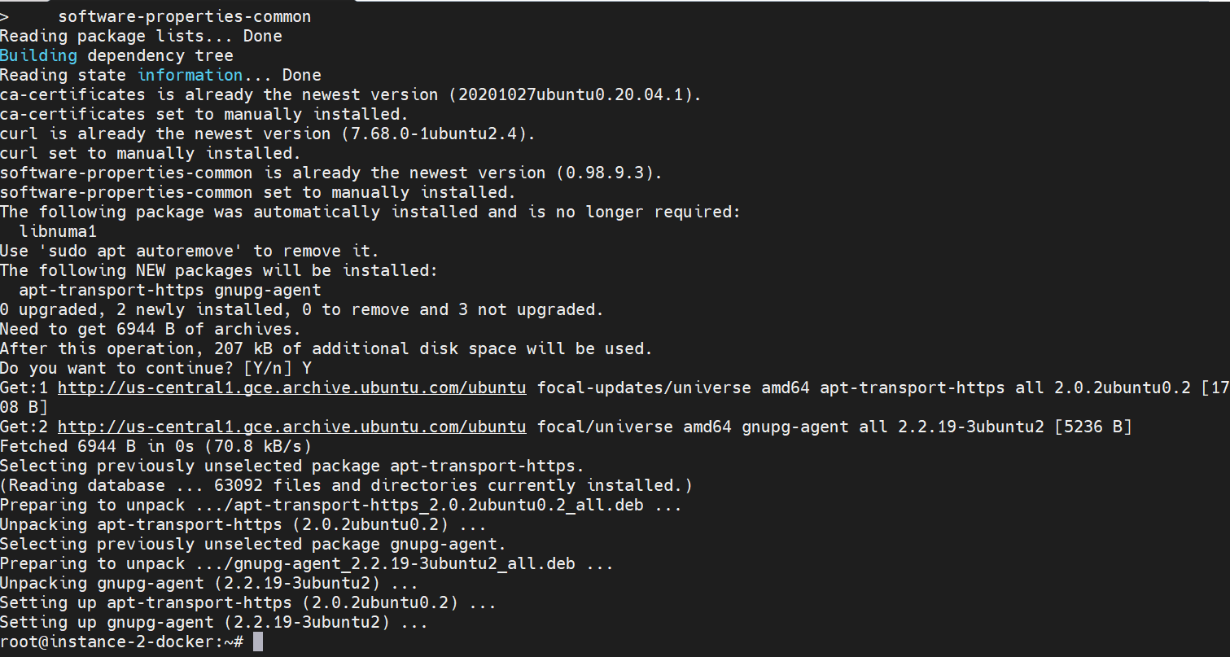

Add Docker’s official GPG key:

$ curl -fsSL https://download.docker.com/linux/ubuntu/gpg | sudo apt-key add -



$ sudo apt-key fingerprint 0EBFCD88

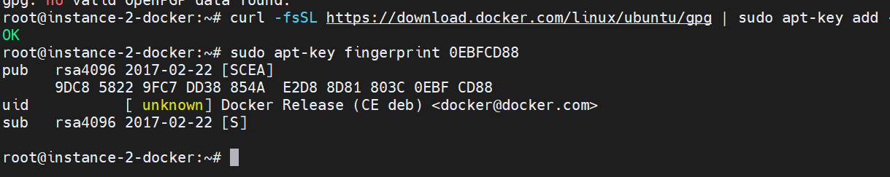

pub rsa4096 2017-02-22 [SCEA]

9DC8 5822 9FC7 DD38 854A E2D8 8D81 803C 0EBF CD88

uid [ unknown] Docker Release (CE deb) <docker@docker.com>

sub rsa4096 2017-02-22 [S]

x86_64 / amd64

$ sudo add-apt-repository \

"deb [arch=amd64] https://download.docker.com/linux/ubuntu \

$(lsb_release -cs) \

stable"

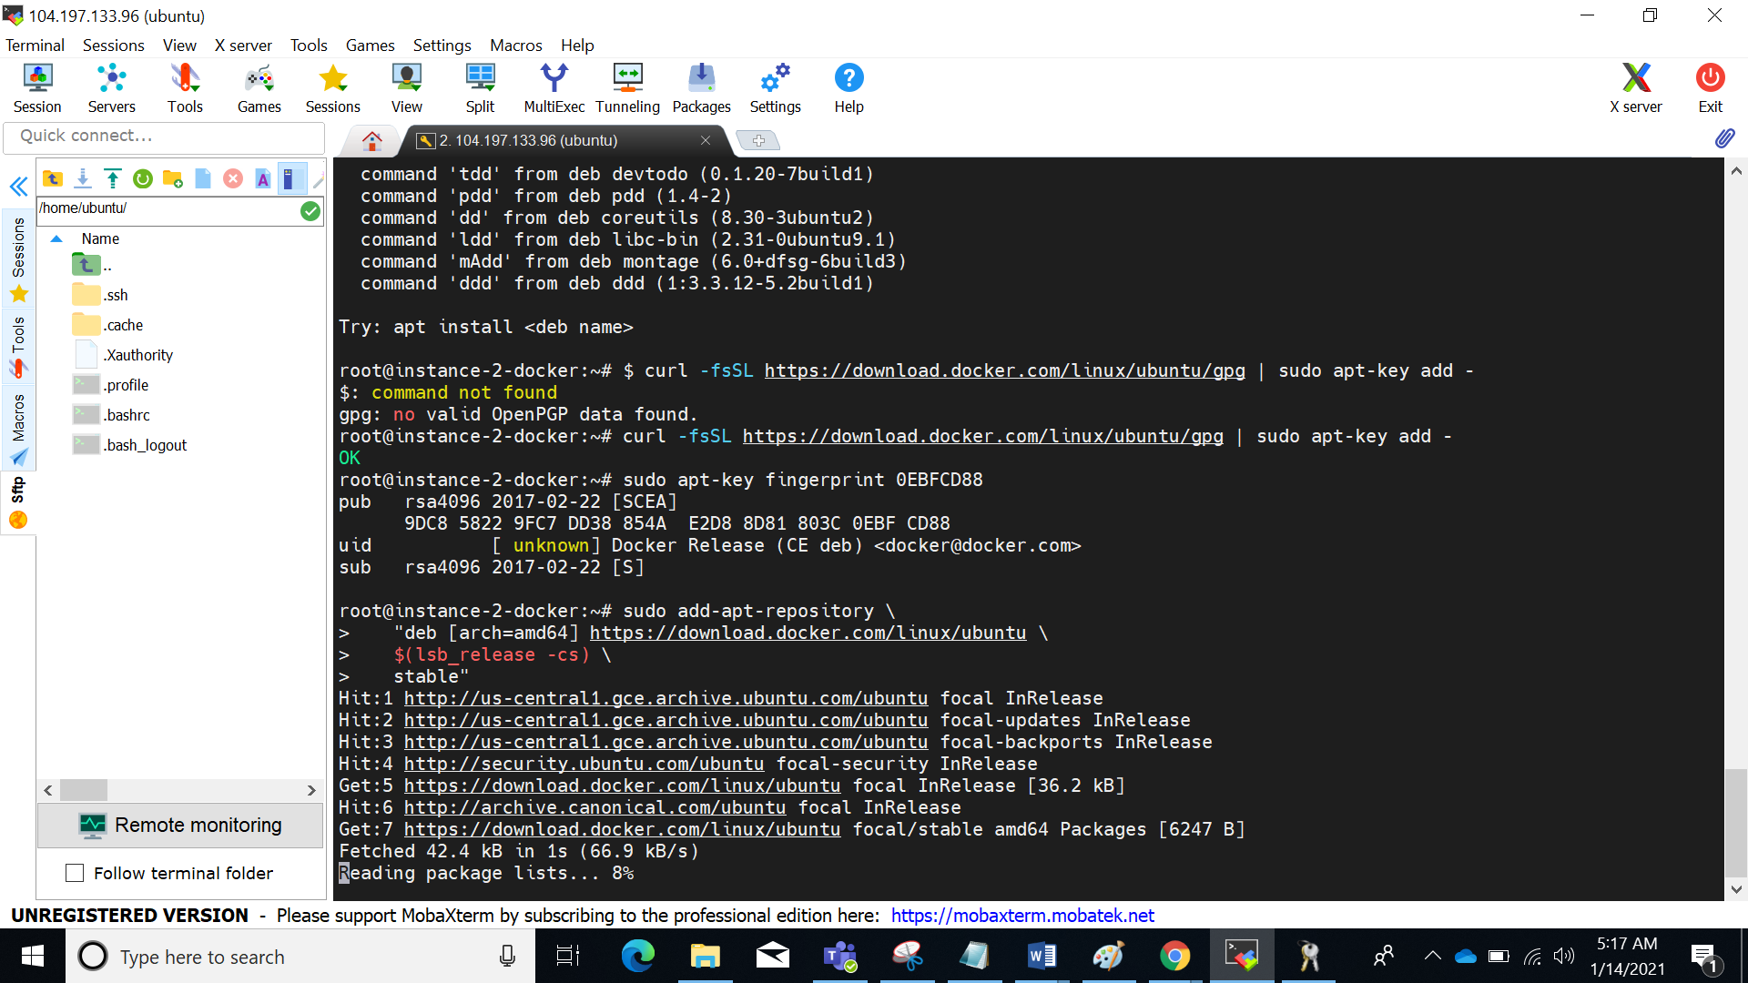

INSTALL DOCKER ENGINE

$ sudo apt-get update

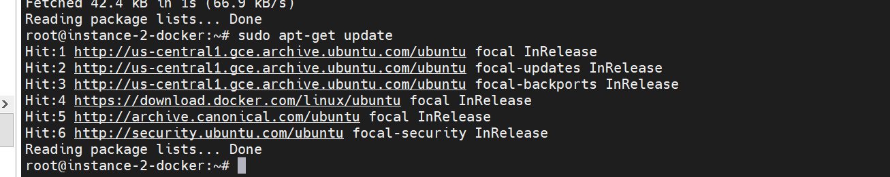

$ sudo apt-get install docker-ce docker-ce-cli containerd.io

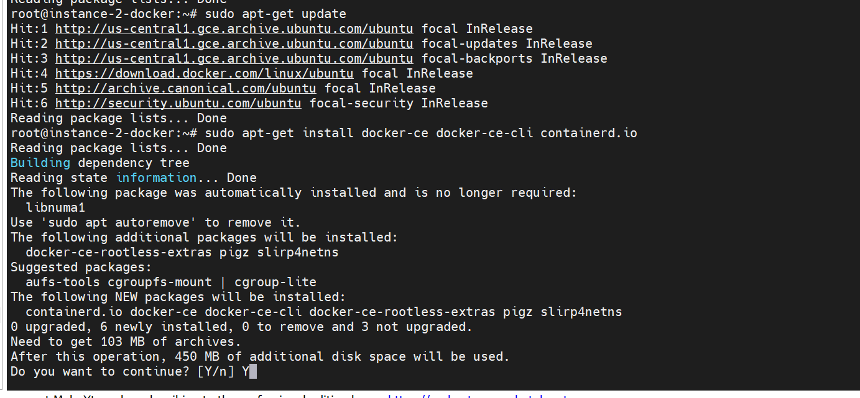

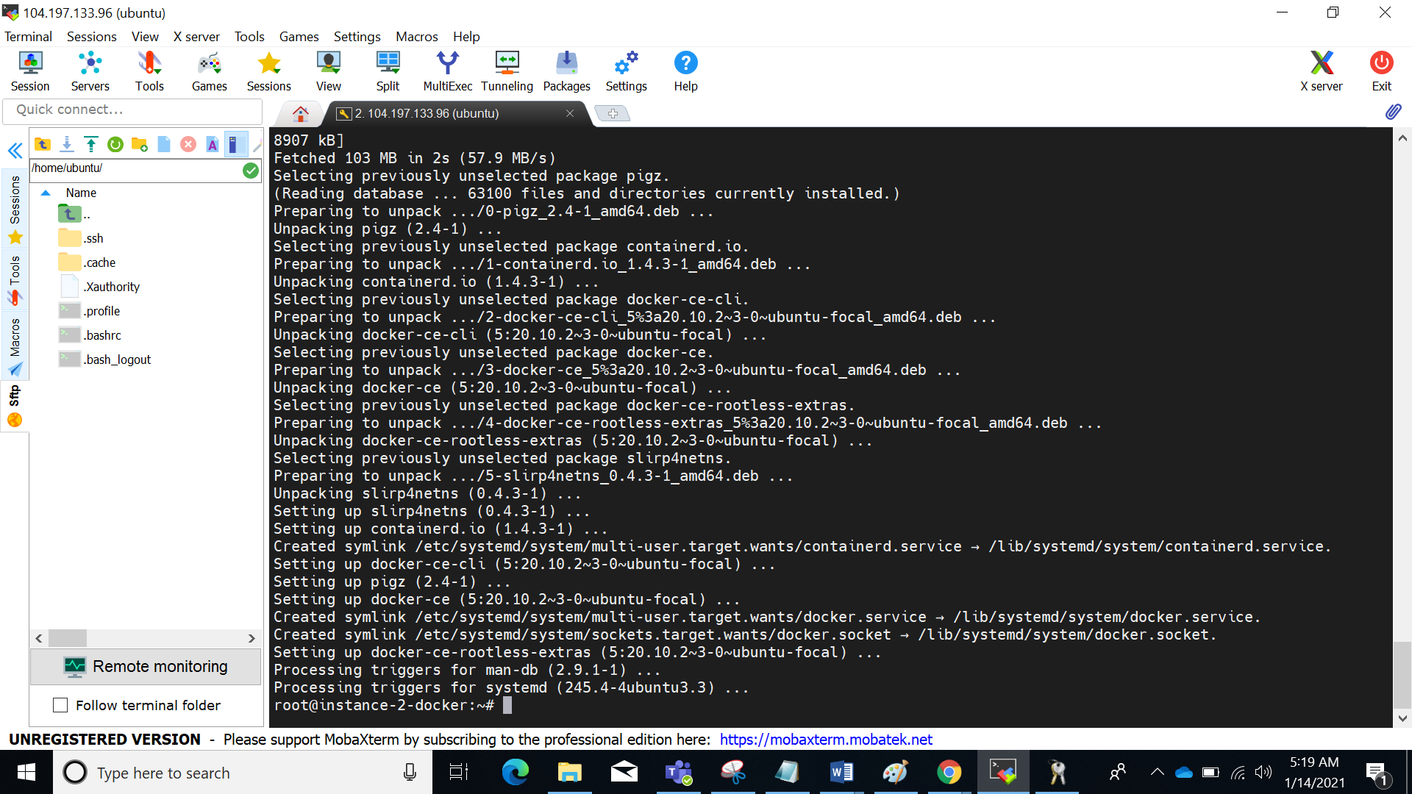

CHANGE THE ROOT

sudo su - ubuntu

check your docker version

docker version

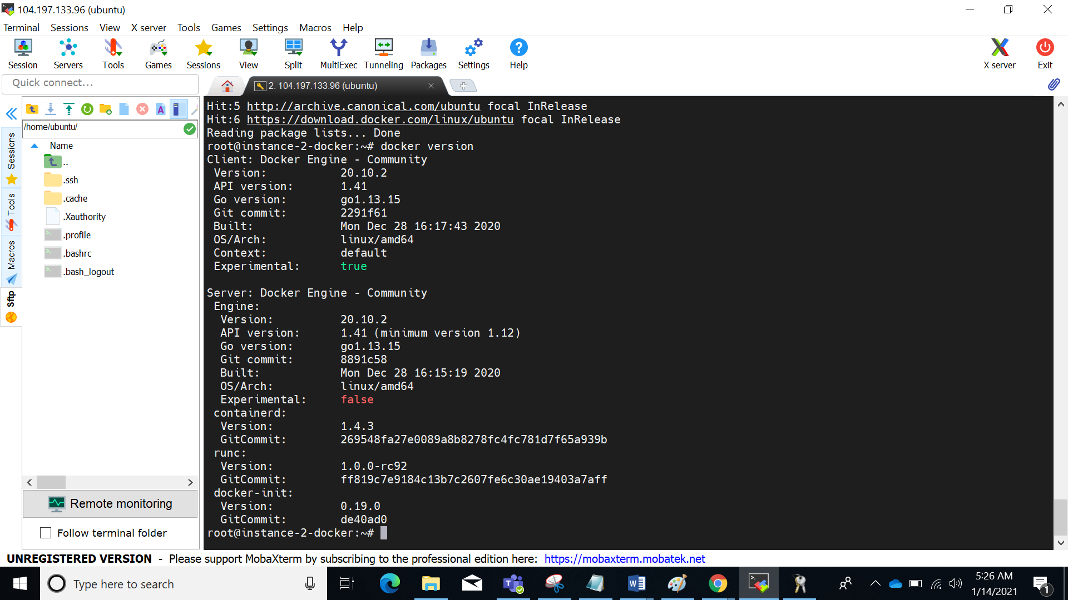

sudo usermod -aG docker $USER && newgrp docker



pull all ayour images

docker run hello-world

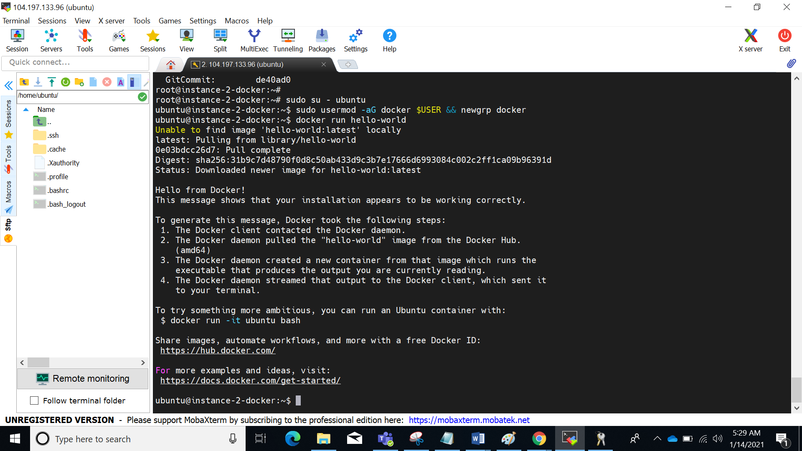

**Steps for Installing Jenkins:**

create volume

docker volume create jenkinsvol

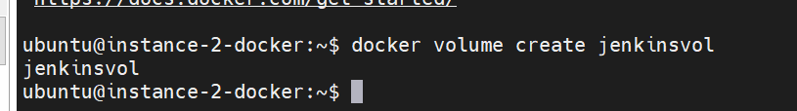

to run your docker

docker run -u root -d --name myjenkins_server -p 9080:8080 -p 9096:9096 -v jenkinsvol:/var/Jenkins_home/workspace jenkins/jenkins:lts

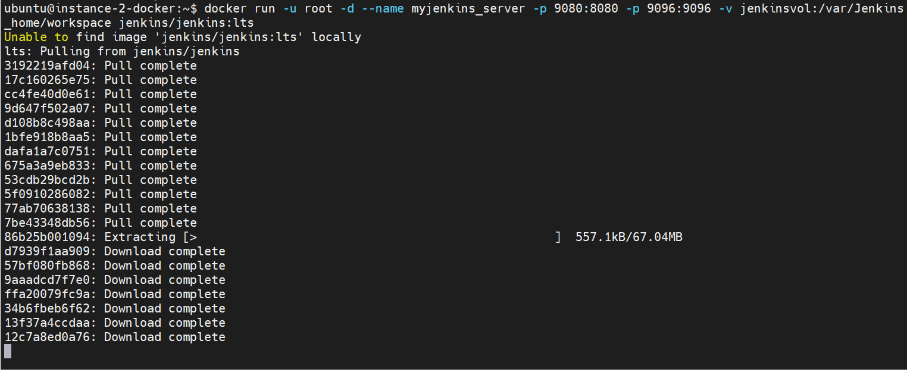

to show all images

docker images

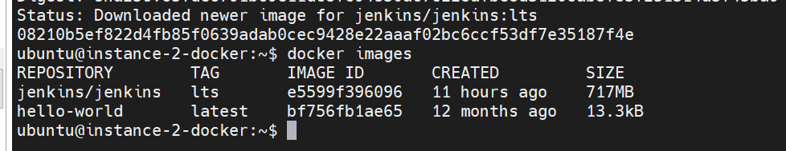

docker ps –a //to show all containers

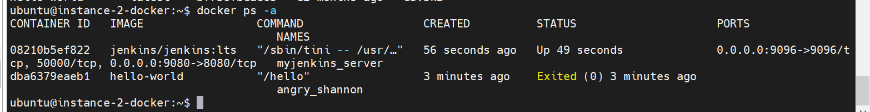

to show what are the running

docker ps

to start the Jenkins as server

docker start myjenkins_server

goto web hit your ip address including port number

curl ipconfig.io

104.197.133.96:9080

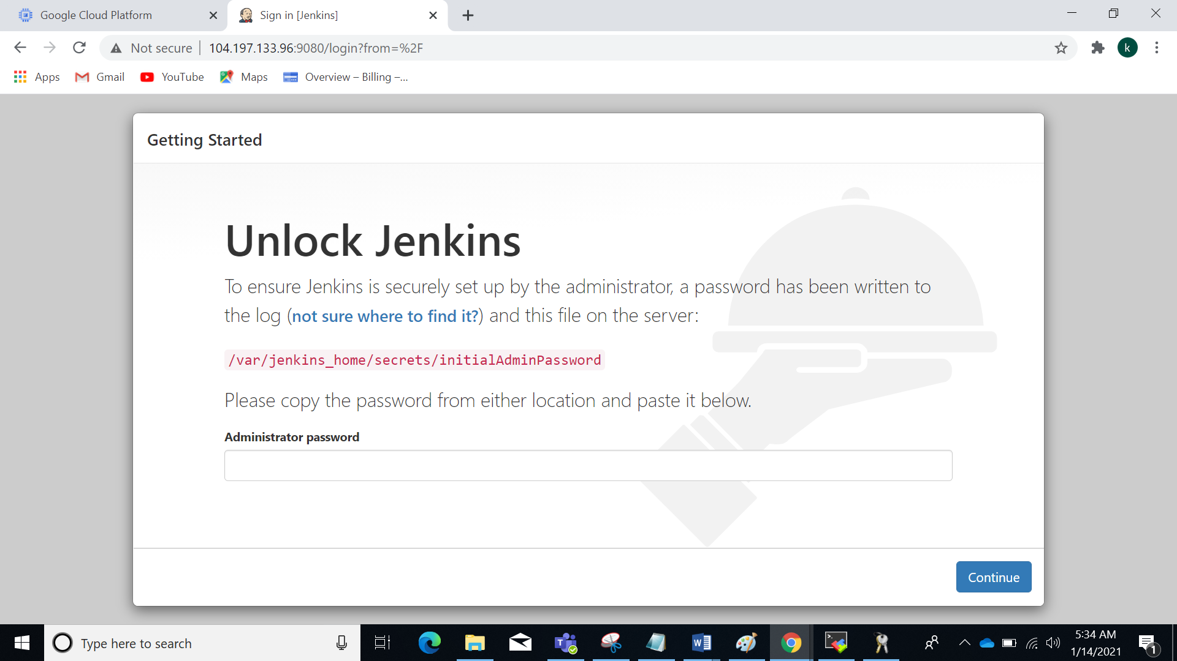

after that for initial admin pwd

docker exec -it myjenkins_server /bin/bash

to know that initial password

cat /var/jenkins_home/secrets/initialAdminPassword

*****************************************

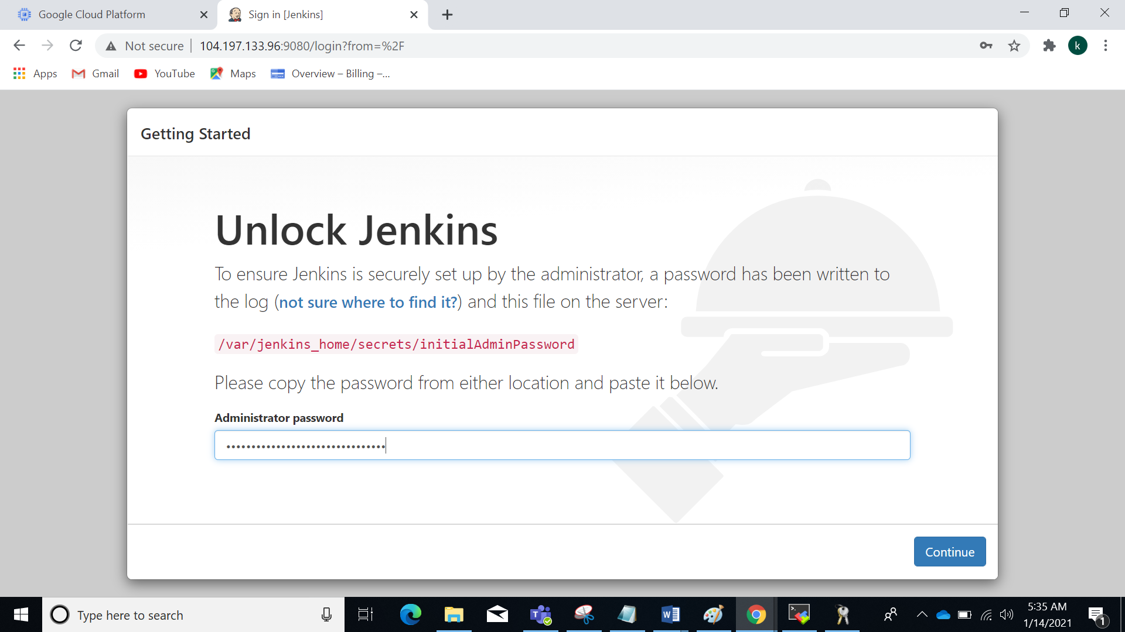

Install suggest plugins

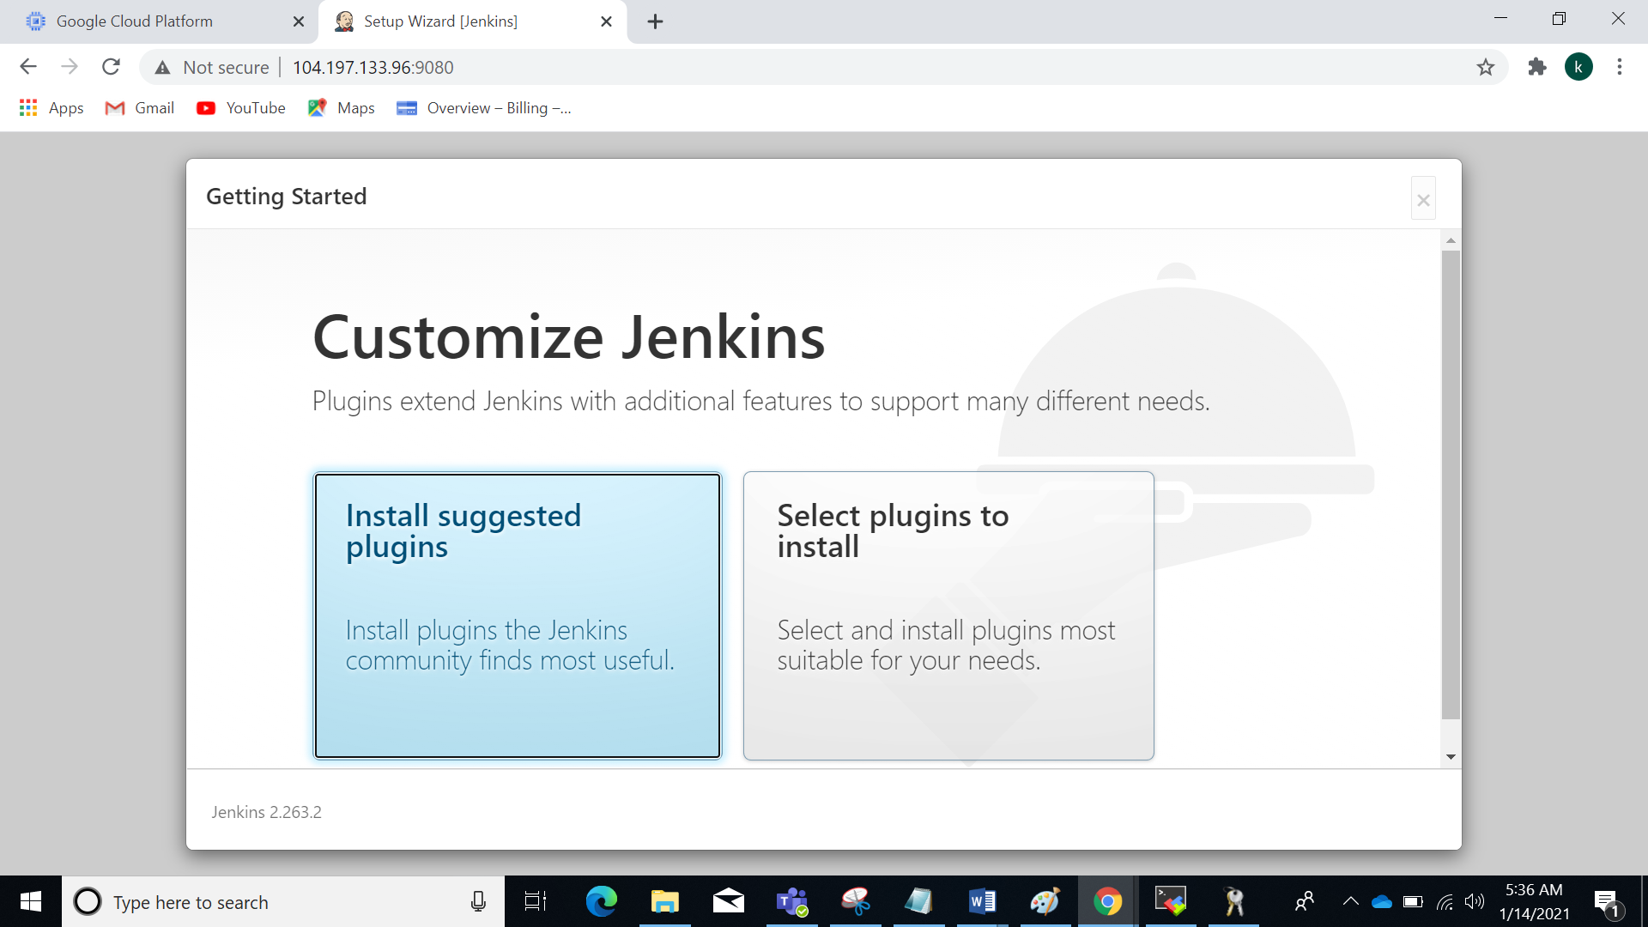

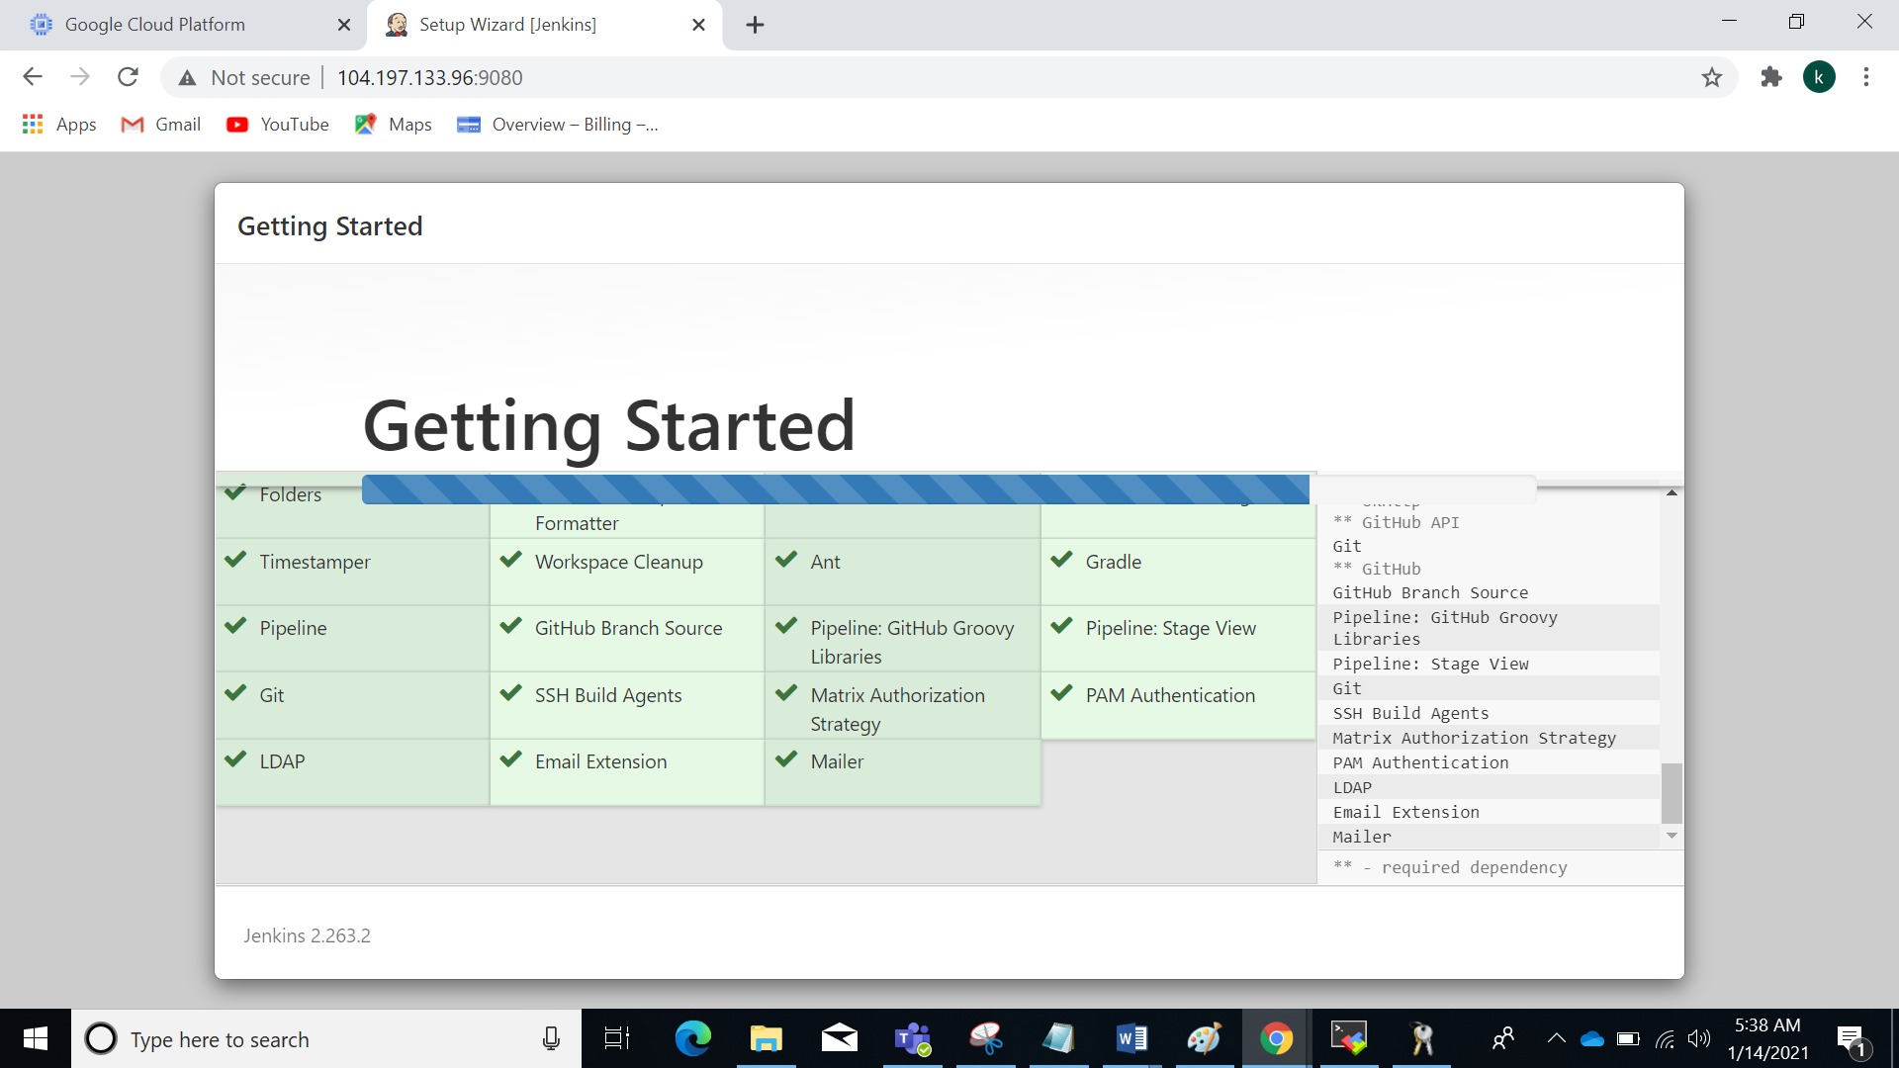

Sign in page : creating the first administrator user

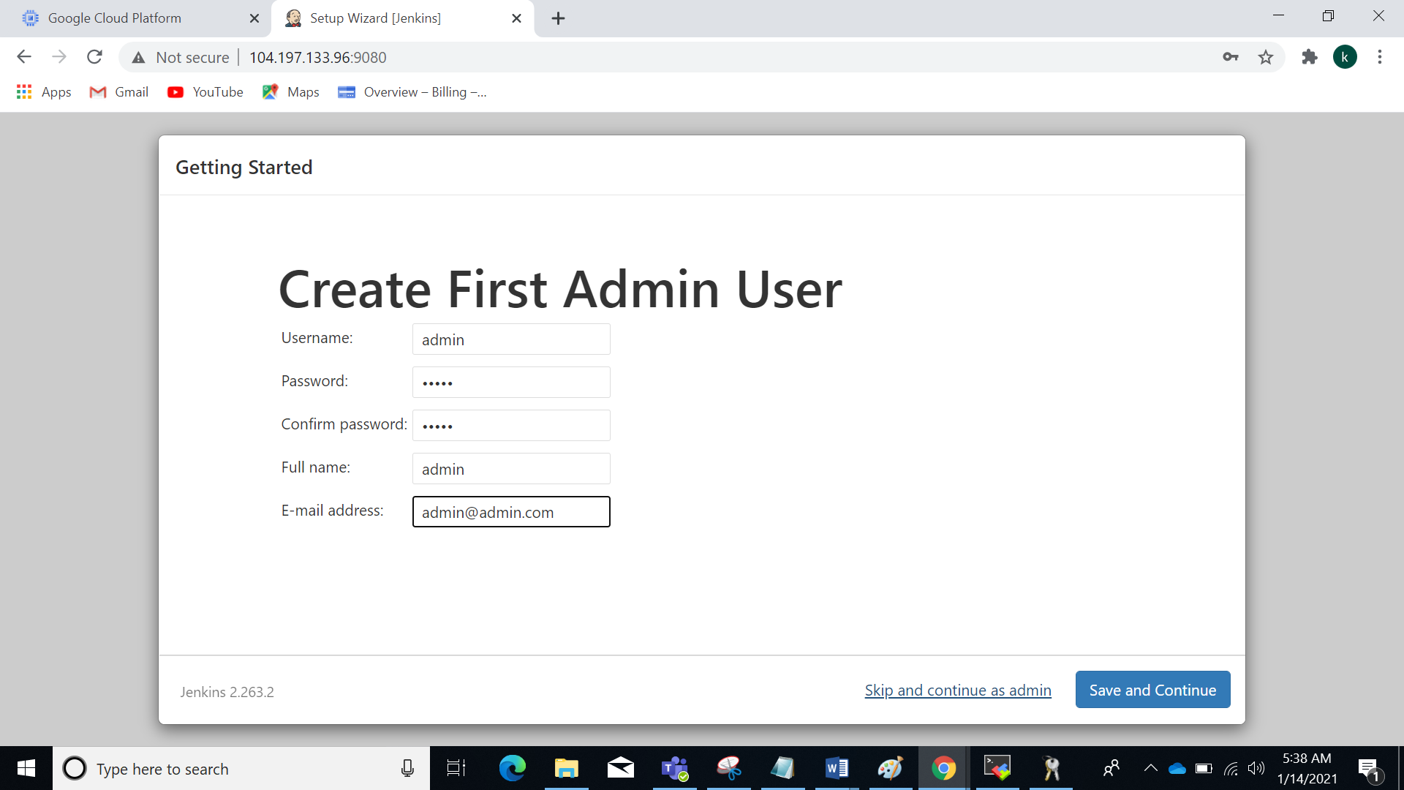

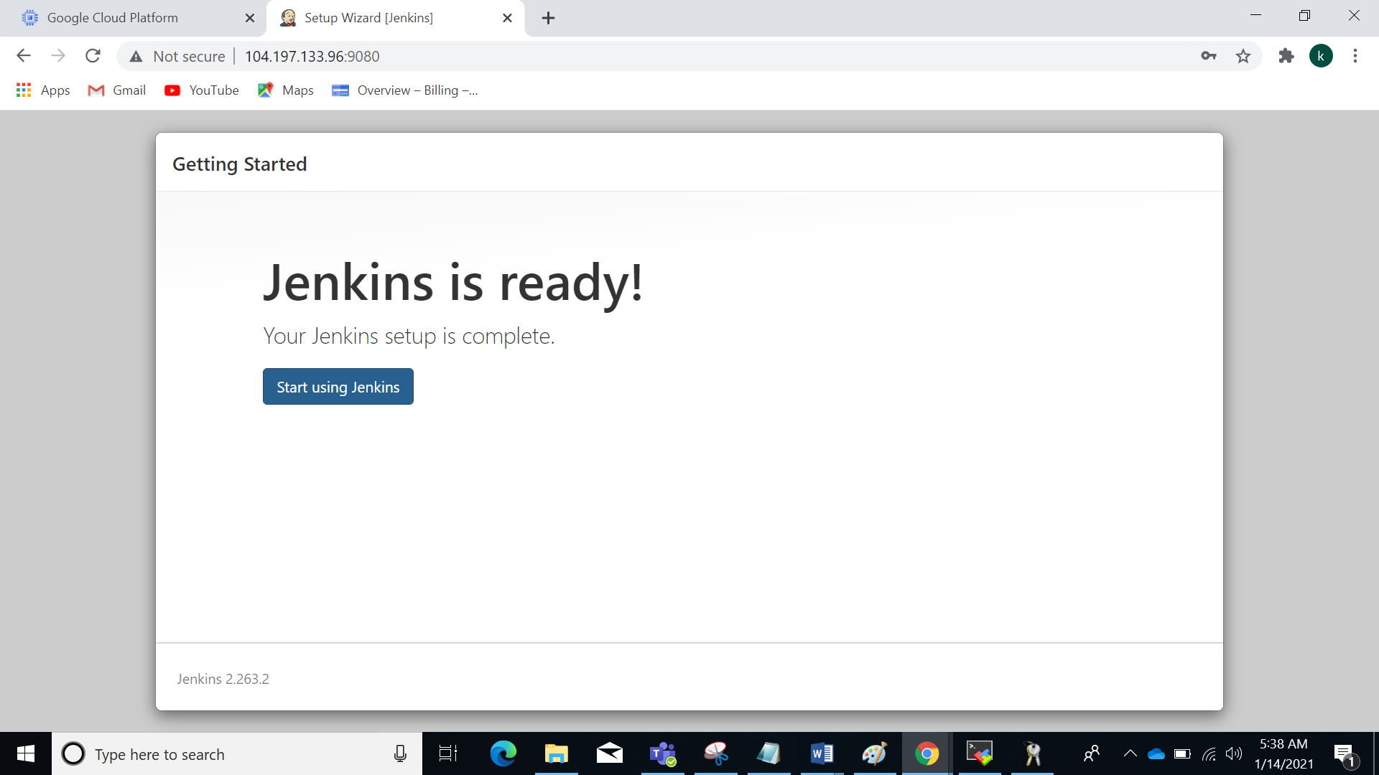

Dafult Jenkins home page

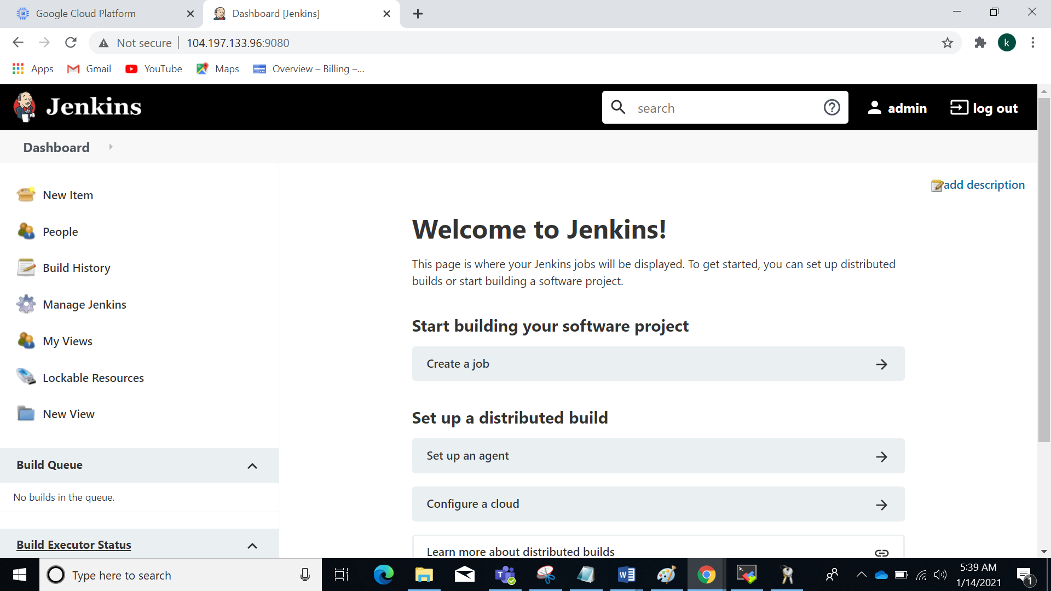

Create Demo JOB:

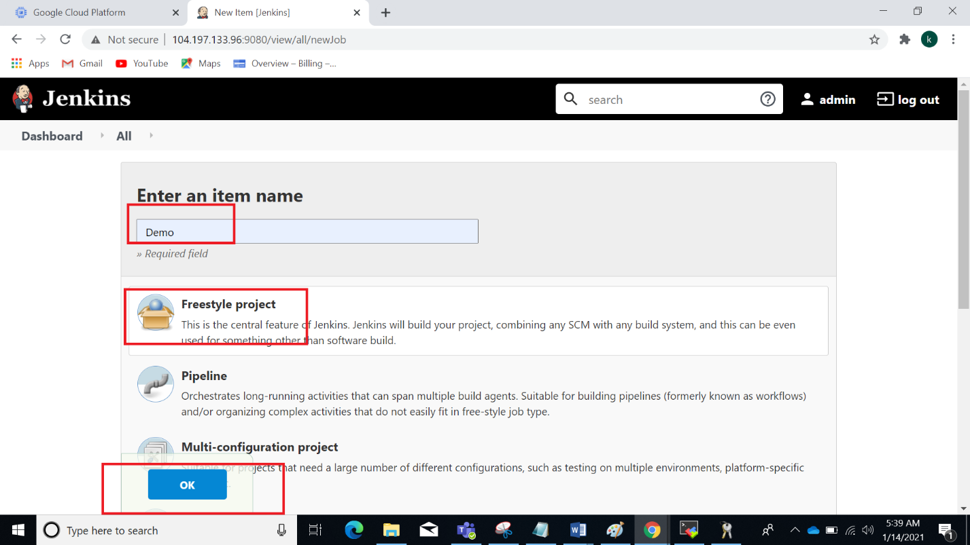

to stop your jenkins

docker stop myjenkins_server



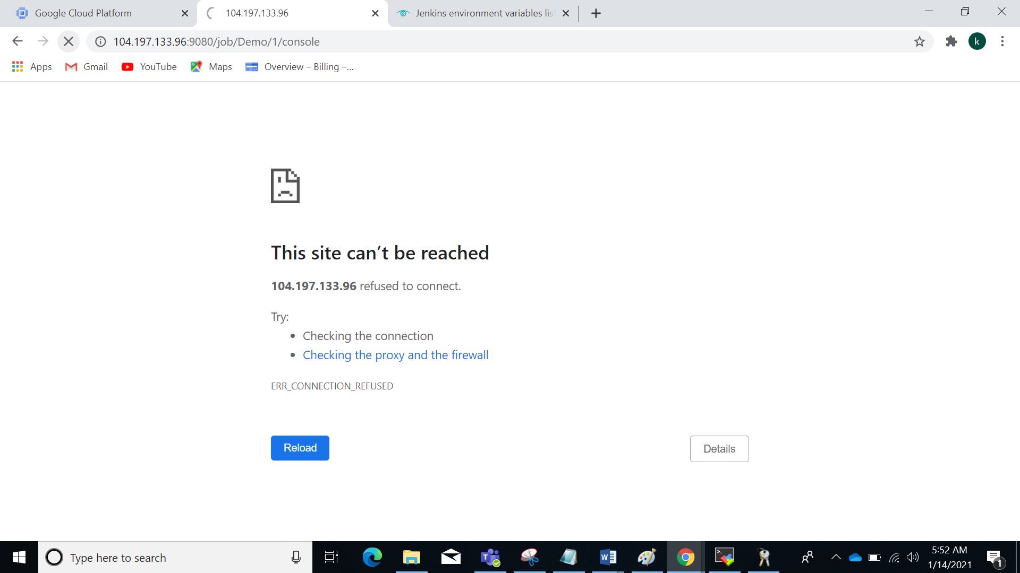

to restart your jenkins

docker start myjenkins_server

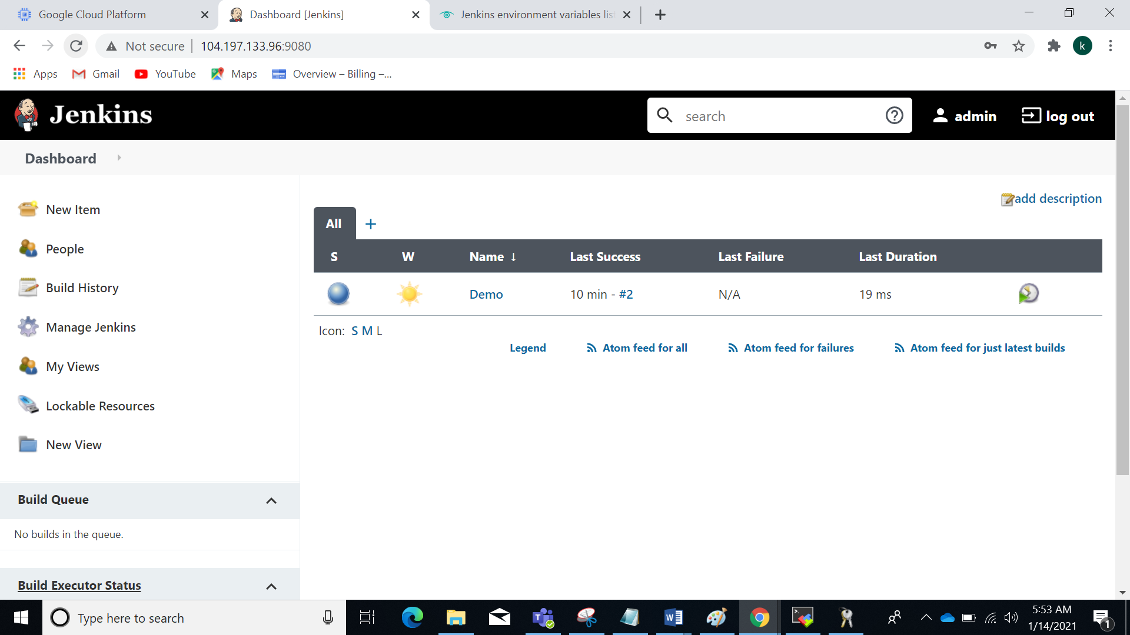

to listen which port is:

sudo lsof -nP -iTCP -sTCP:LISTEN

//////////////////

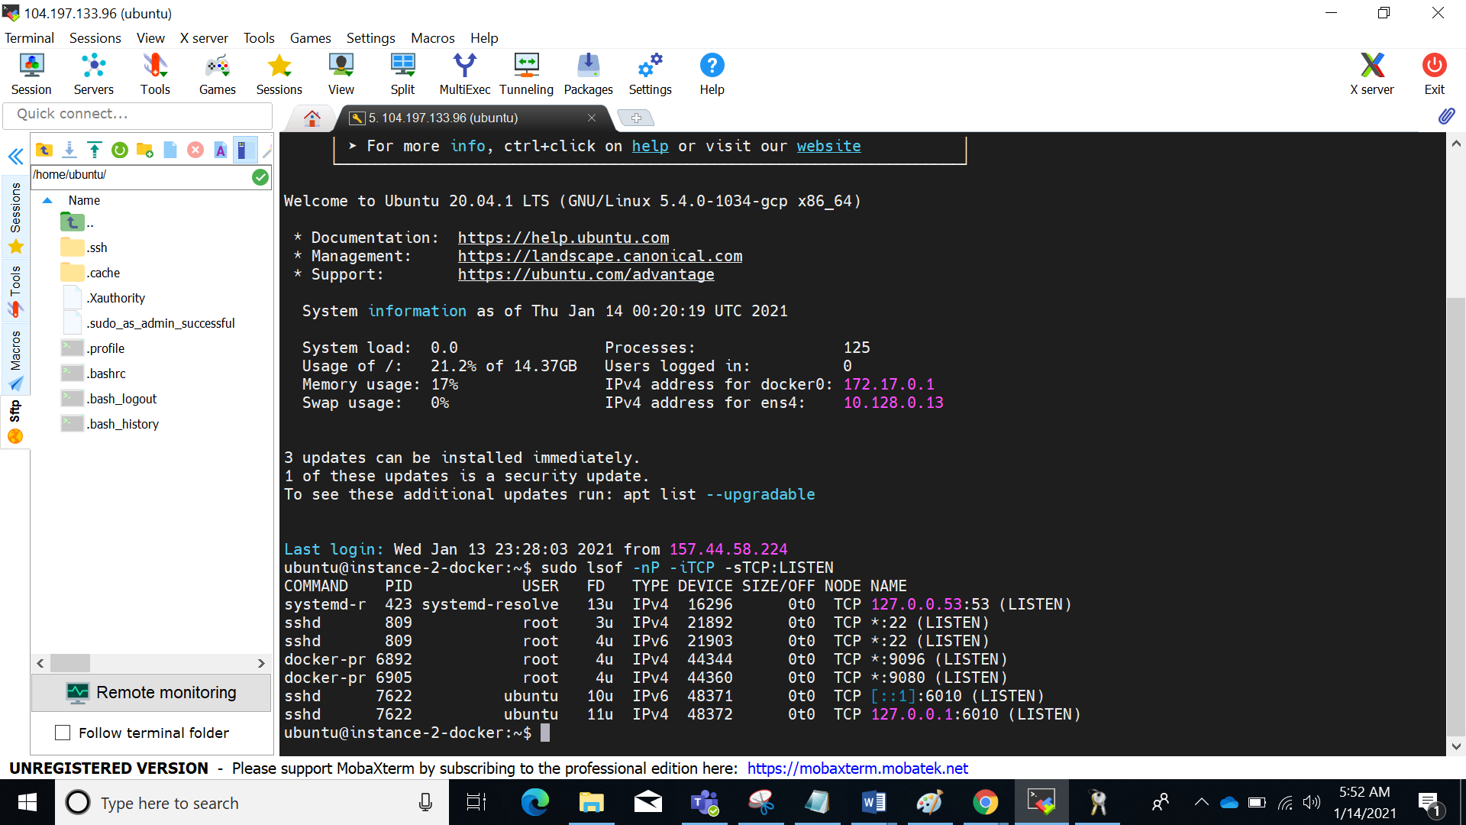

Jenkins

1. Create Freestyle Job in Jenkins to print Env variables (10 env variables)

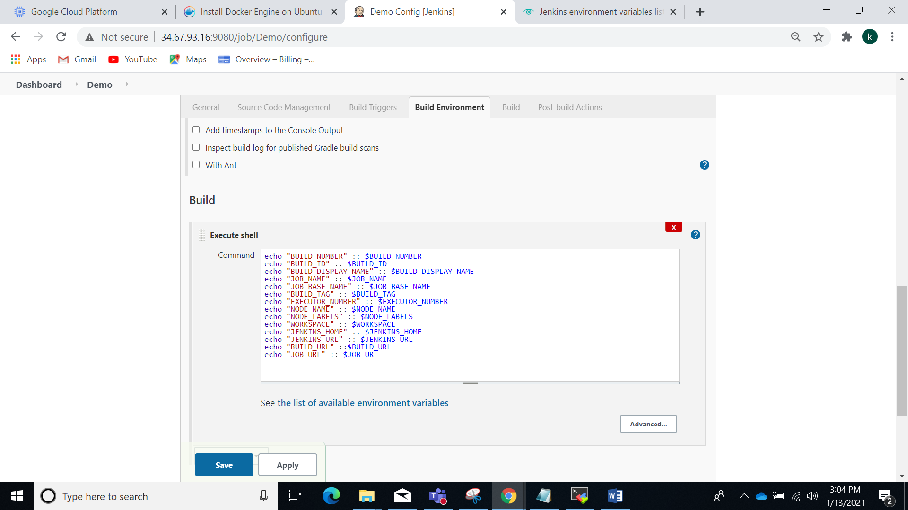

Console output:

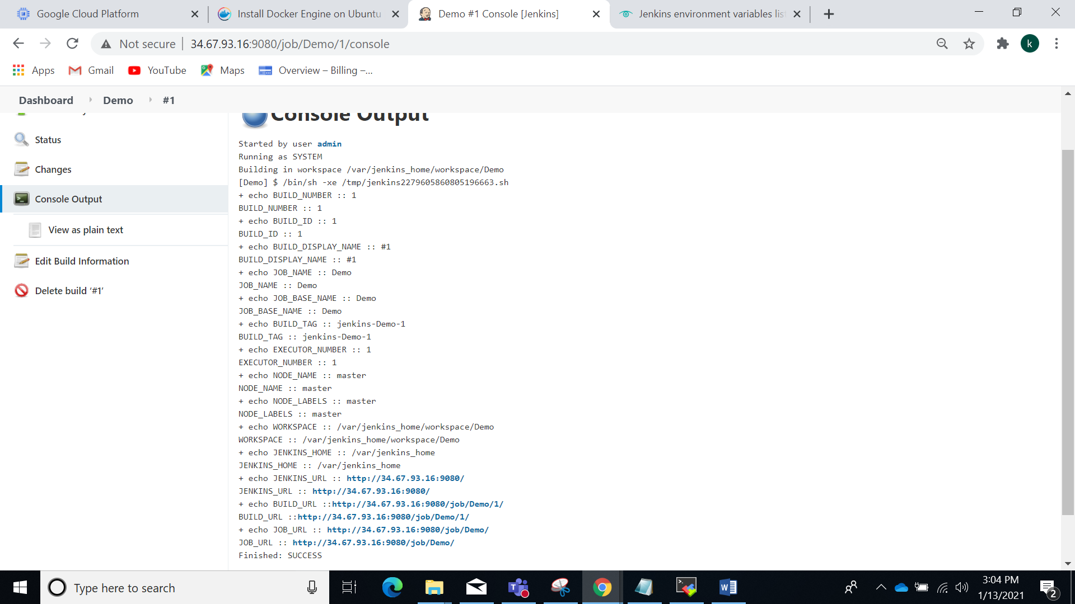

2)Create a Parameterized Job (Free Style) i.e. One string / boolean / Choice and display the values

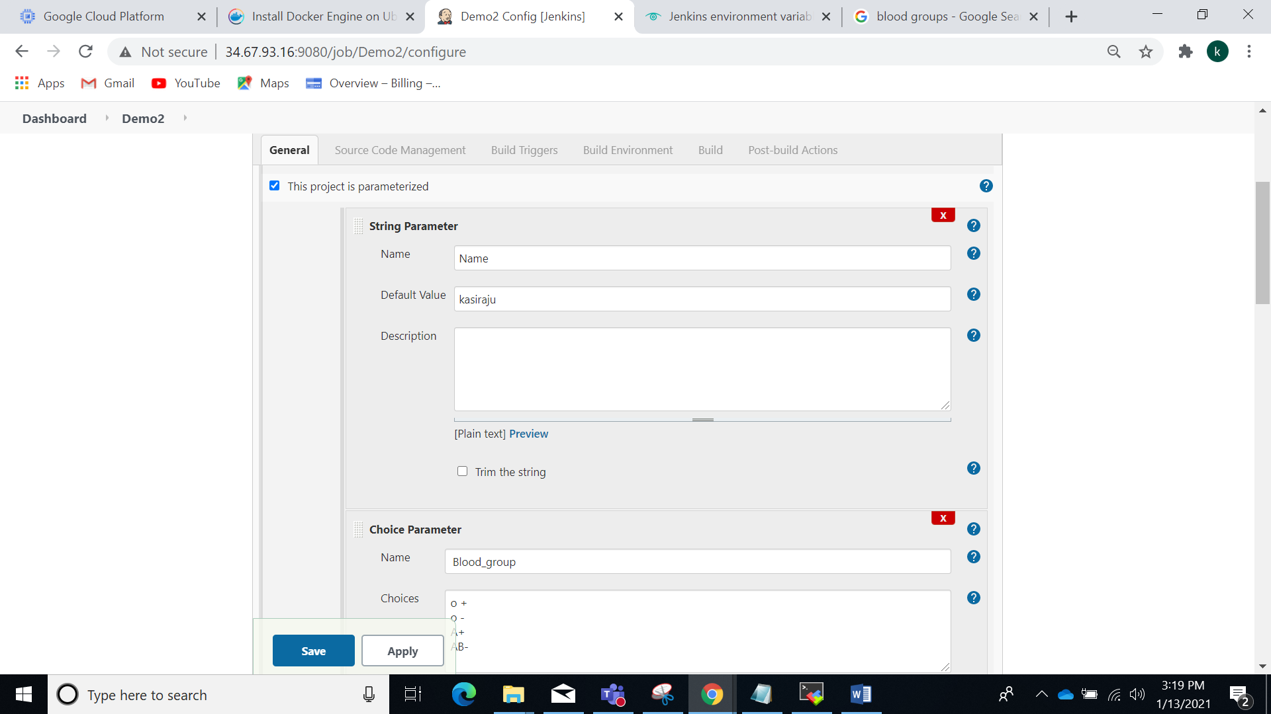

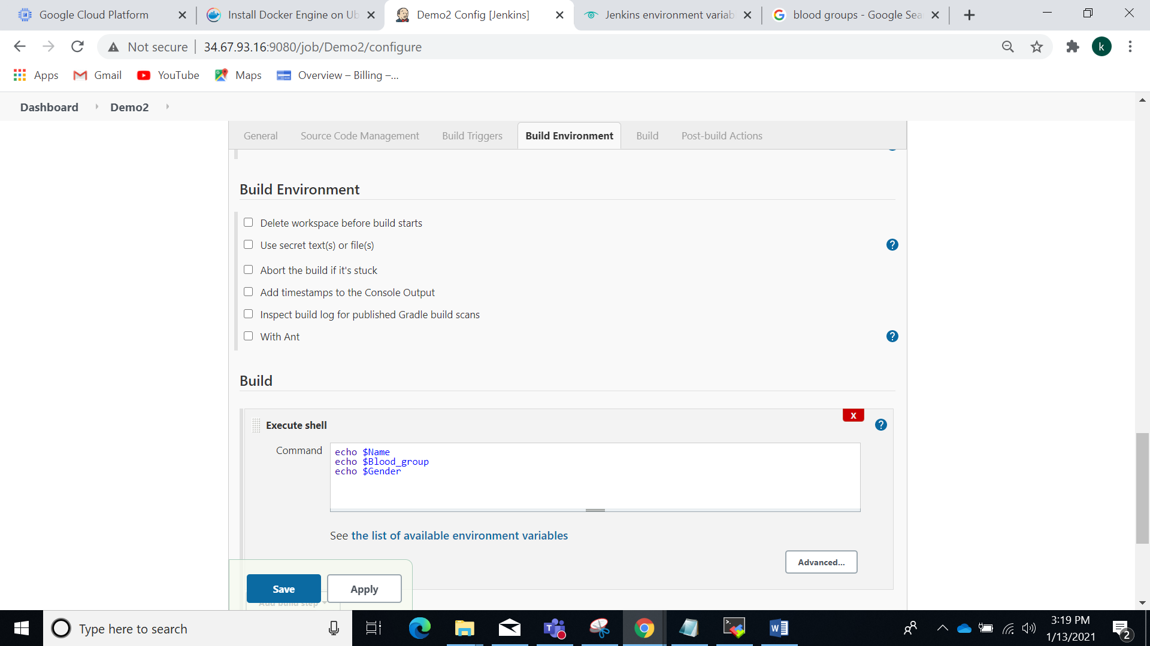

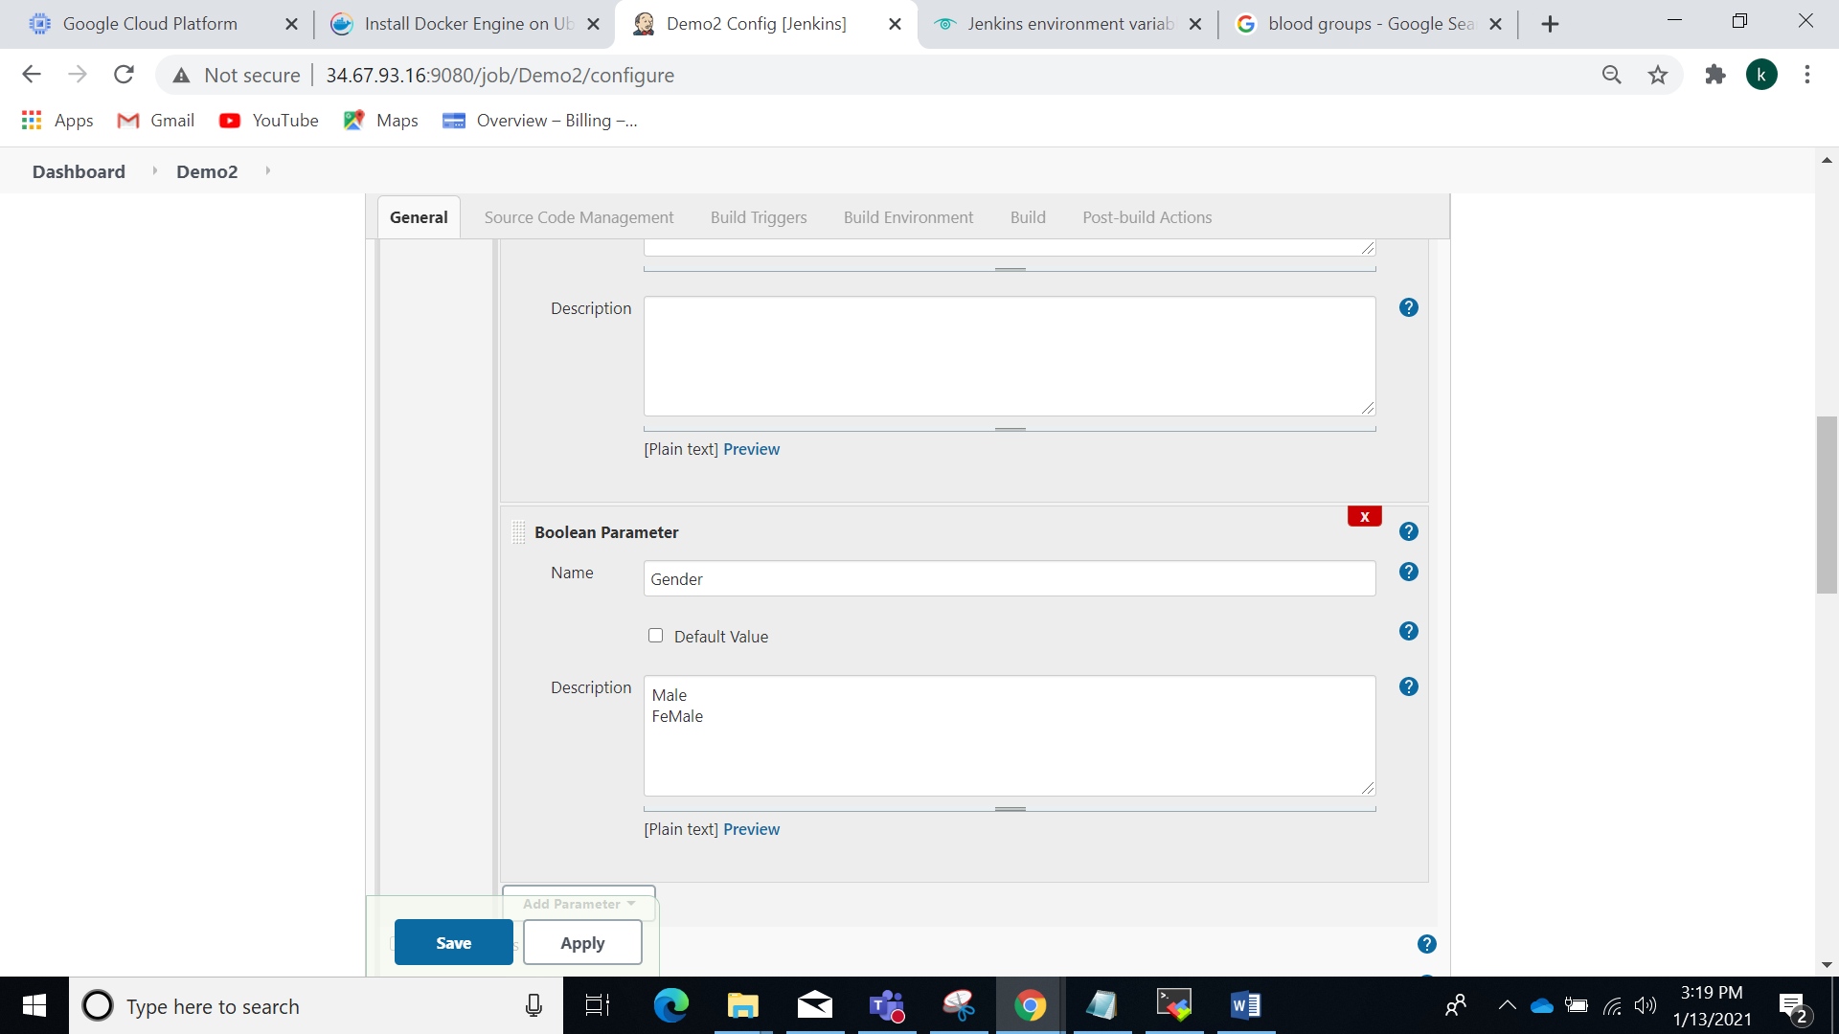

Final console output:

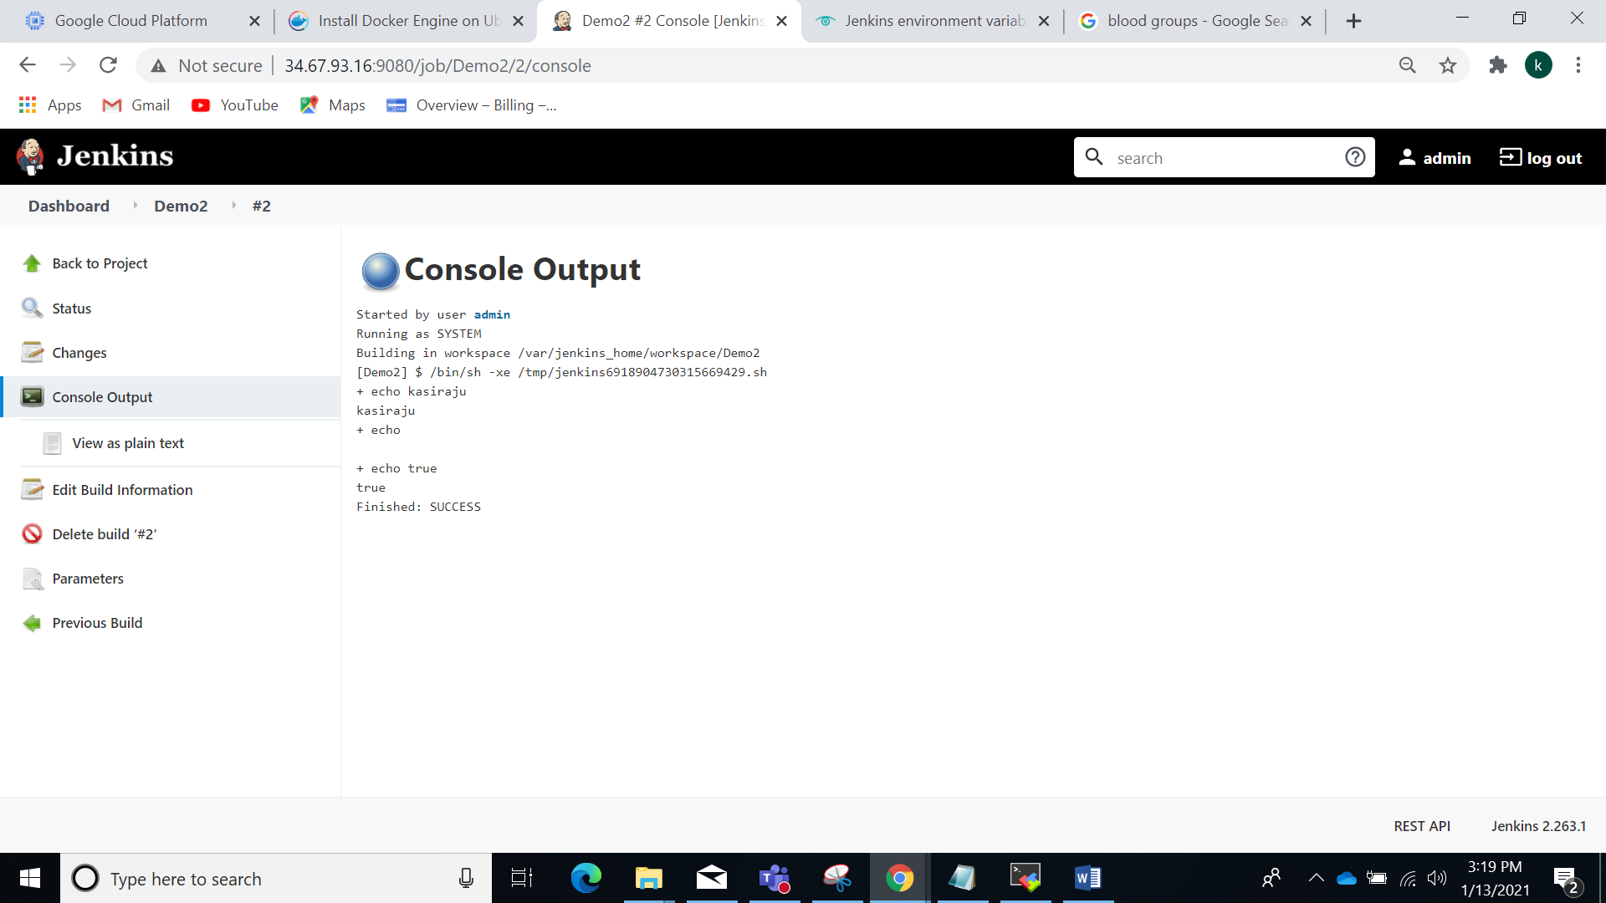

1. Create Freestyle Job in Jenkins to print Env variables (10 env variables) and schedule this for every 15 mins:

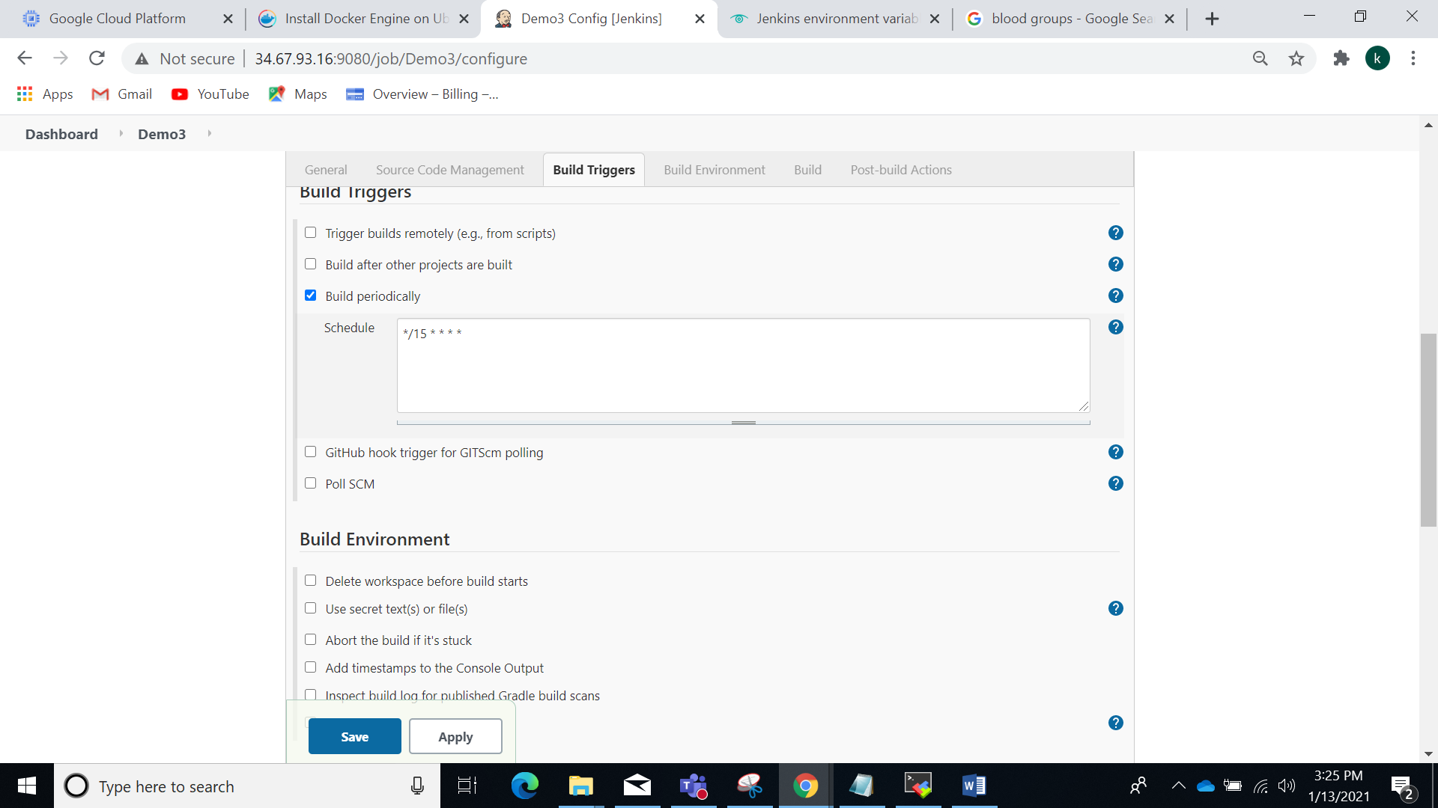

Console output:

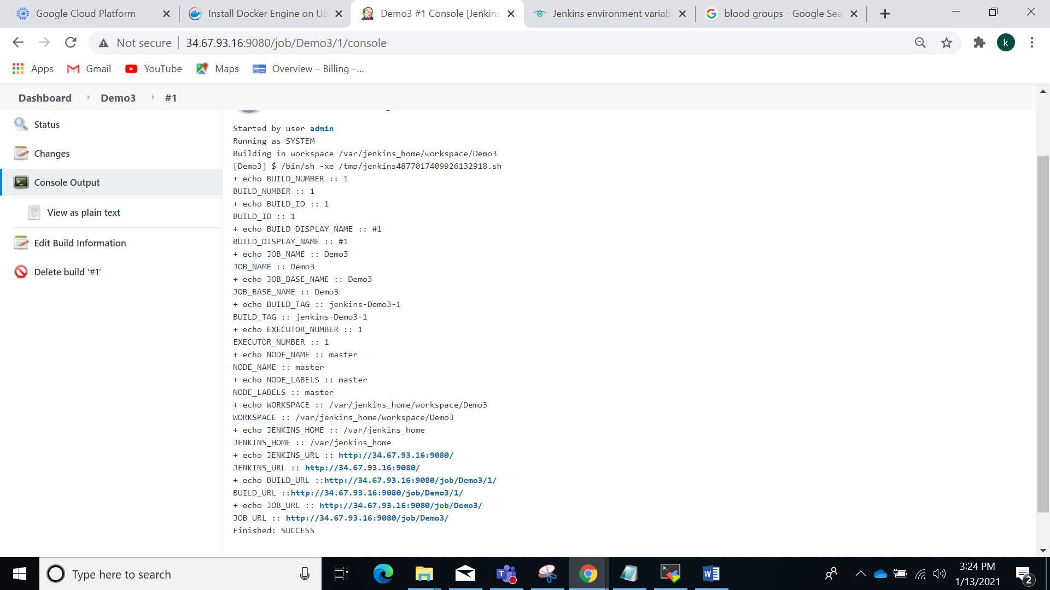

1. Fork this repository and build

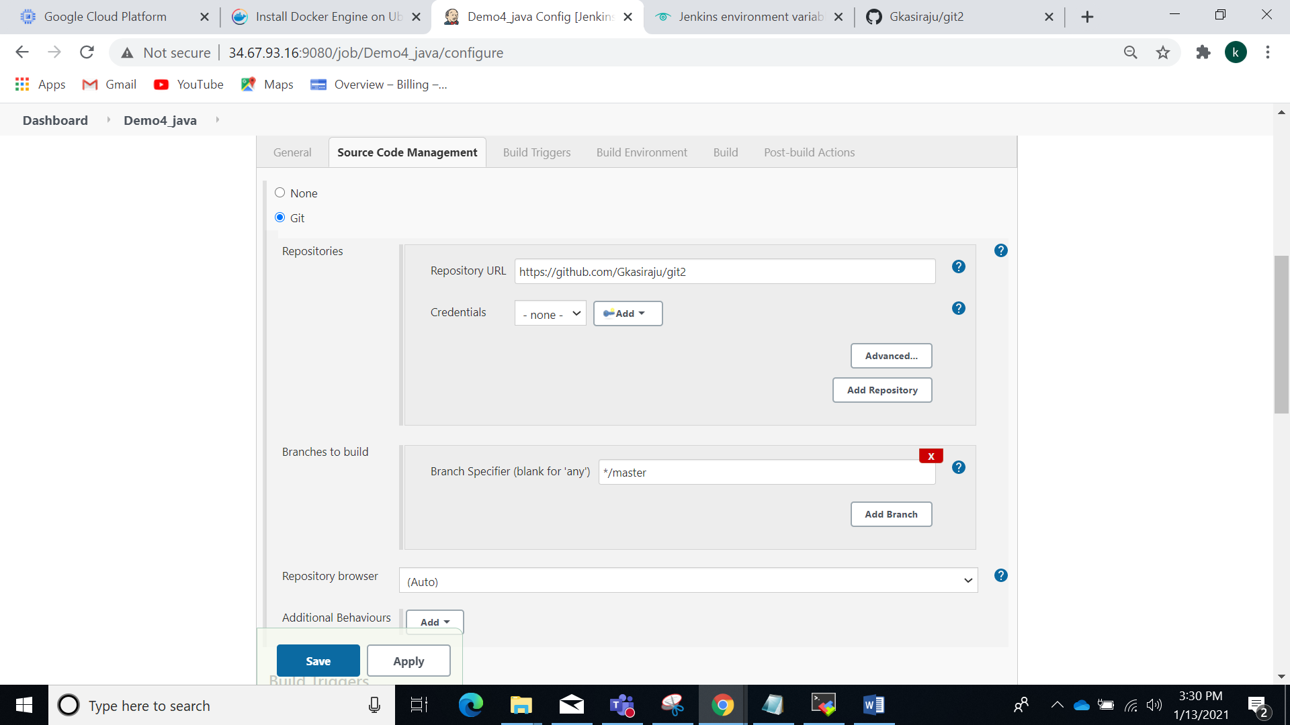

Console output:

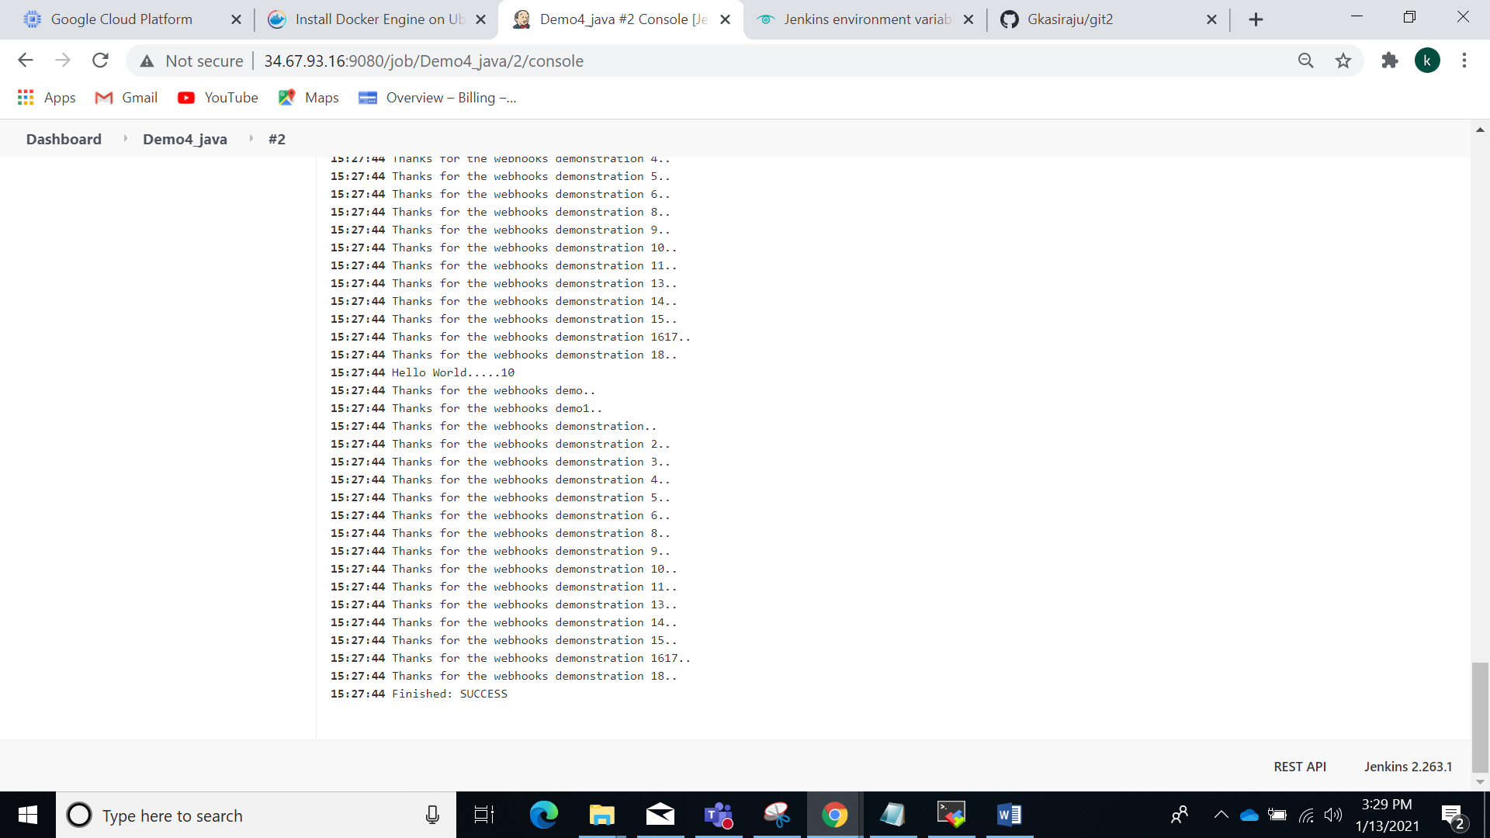

5)By using Webhook signal

Before the webhook signal

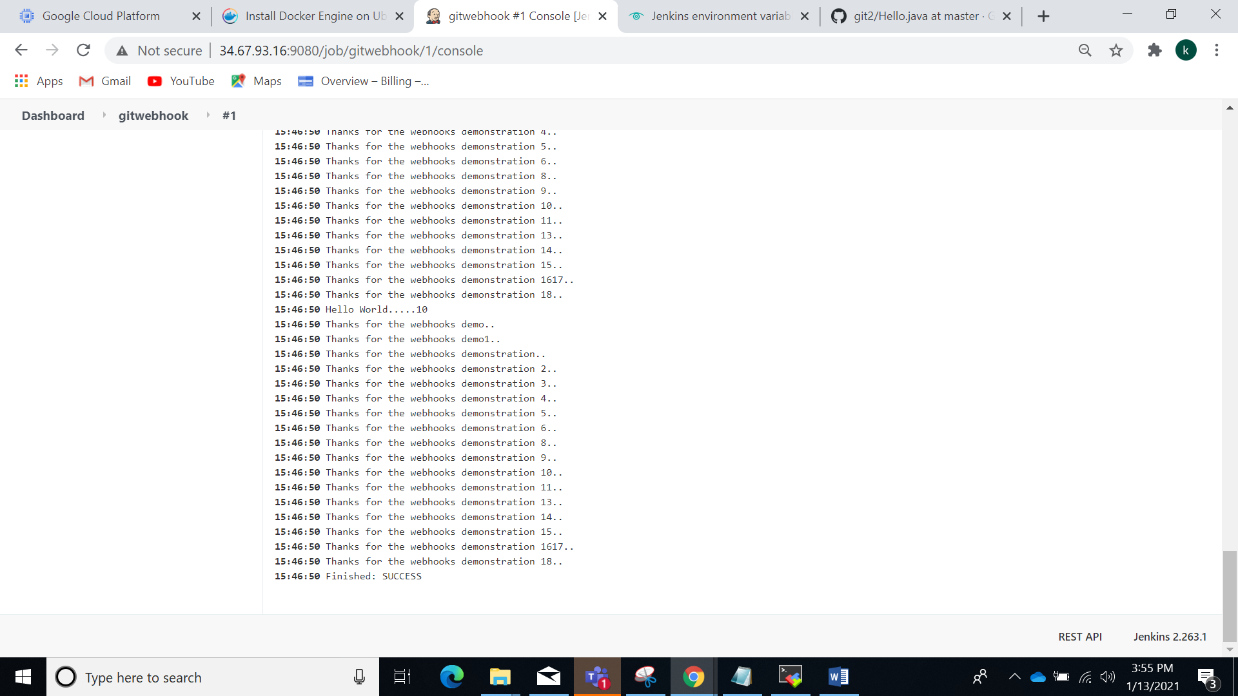

After changes in github: build triggered

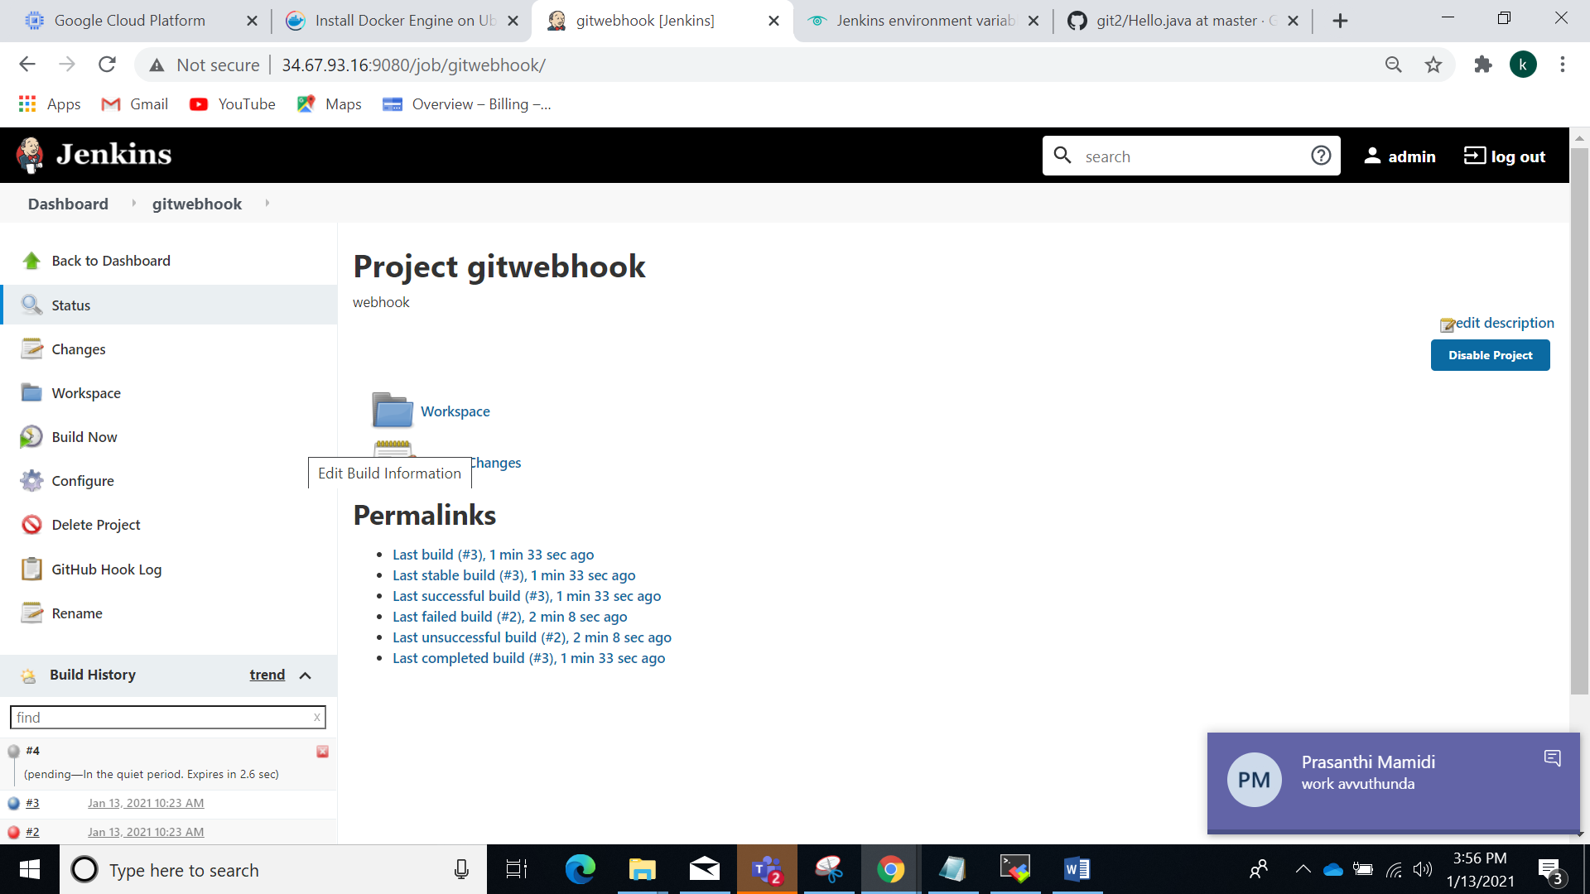

Console output

